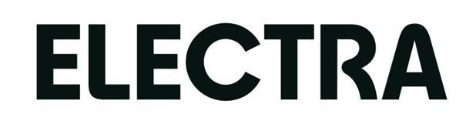

Confidential and under embargo until 2024 January 15 at 5:00 PM

Paris, January 15, 2024

Electra raises €304 million of capital
to accelerate the switch towards electric mobility in Europe
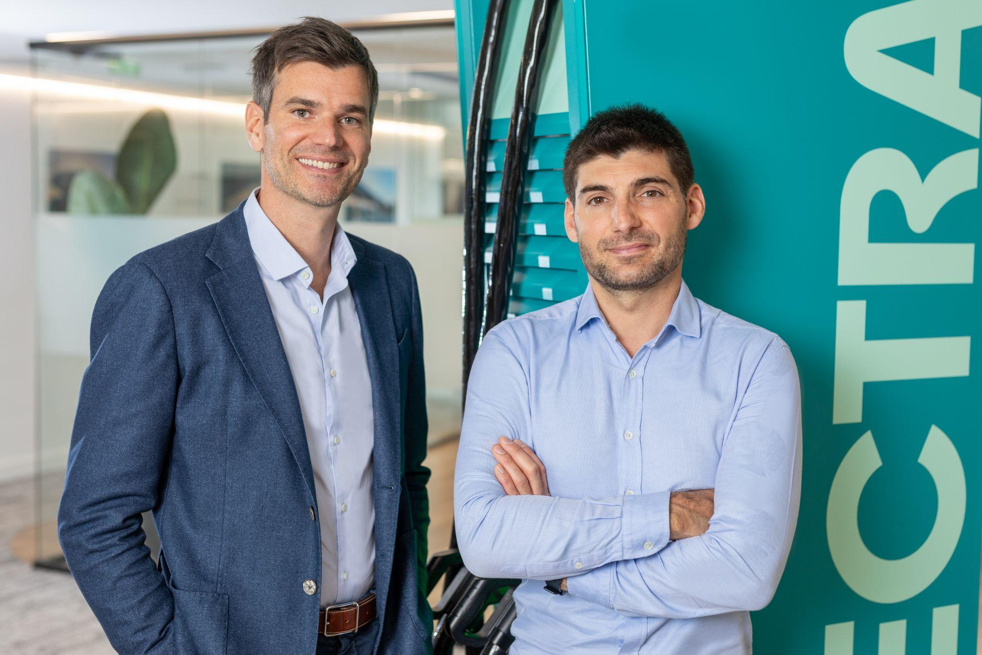

Electra, the European fast-charging network for electric vehicles, announces a fundraising of €304 million, entirely in equity, a record amount in the charging sector. This funding round is led by the Dutch pension fund service provider, PGGM. Bpifrance, through its Large Venture fund, also enters Electra's capital on this occasion. Historical investors, especially Eurazeo, RIVE Private Investment, the SNCF group, and Serena, participate in this round. Electra has raised nearly €600 million in capital in 3 years to deploy one of the first charging networks at the European level.
Trust from leading partners
This €304 million fundraising is the largest in France and the second-largest in Europe in the charging sector. The round is led by a new investor, PGGM, a Dutch pension fund service provider, among the largest asset managers in Europe, through the "PGGM Infrastructure Fund."
On this occasion, historical investors, including Eurazeo, RIVE Private Investment, the SNCF group through 574 Invest, and Serena, renew their trust in Electra after participating in previous fundraising rounds.
Bpifrance also participates in the round through its Large Venture fund. This participation reflects Bpifrance's commitment, as a climate bank, to support a French player like Electra (laureate of the French Tech Next 40 and the France 2030 call for projects), able to become a champion of sustainable mobility in Europe.
Electra moreover benefits from the financial support of leading public and private investors such as EIP in Switzerland, RATP Capital Innovation, Caisse des Dépôts et Consignation/ Banque des Territoires, Ademe Investissement, Eiffel Investment Group, RGreen Invest, Frst, Allianz, Groupe Chopard and Altarea in France.
The company has also formed numerous strategic partnerships with recognized players, including Indigo, VINCI Autoroutes, Altarea, AccorInvest, Louvre Hôtels Groupe, the Delhaize group, Toulouse Blagnac Airport, InVivo, Groupe Chopard, Stellantis, G7, Bolt, Europcar, Sixt, Honda, MG, and Hertz.
Ambition to deploy 2,200 stations with 15,000 charging points, throughout Europe by 2030
The European electric vehicle fleet is set to grow significantly, notably due to the prohibition of new internal combustion engine car sales from 2035. It is imperative that the charging infrastructure fastly expands to accompany this growth, as nearly 30 million electric vehicles are expected to be on European roads by 2030.
Electra supports this transition to cleaner vehicles by massively deploying fast, reliable, and user-friendly charging stations.
Electra's strengths in this equipment race?
- 100% proprietary technology. With software being key to the proper functioning of charging stations, Electra is currently the highest-rated charging network by users.
- A "pure player" focused 100% on fast charging. Similar to certain automakers leading in vehicles, this specialized structure allows for innovation and faster progress.
The company is experiencing fast and sustained growth, present in 8 countries: France, Germany, Belgium, Luxembourg, Italy, Switzerland, Austria, and Spain, with nearly 1,000 charging points already deployed. Electra has quickly gained popularity due to the simplicity of its station usage, recording nearly 100,000 charging sessions per month. It is mainly present in large urban areas in supermarket parking lots, restaurants, hotels, or public parking spaces, and has opened the first charging station at an airport (Toulouse Blagnac) and several stations on highway rest areas.
This fundraising now gives Electra the means to realize its ambition of installing 15,000 charging points by 2030 in Europe and developing numerous services with the ultimate goal of making charging as simple as refueling with gasoline but much more user-friendly.
Indeed, since its inception, Electra stands out with massive investments in innovation and research to create the best charging experience in the market. A team of 180 experts, including 40 software engineers, works every day to facilitate user charging. For example, Electra has invented the reservation of charging points, allowing everyone to find a station near their home and optimize their time during daily activities. Electra is also the preferred partner for professionals with many rotations (delivery drivers, taxis, etc.) who can recharge easily, benefit from services developed by Electra, and enjoy dedicated rates.

Dennis van Alphen, Head of Infrastructure Investments at PGGM, explains: “ PGGM Infrastructure Fund fully supports Electra's ambition to become a pan-European player in the market of (ultra)fast charging facilities for EVs. The enterprise has excellent management and a strong position with good locations in a very dynamic market that is expected to grow rapidly in Europe in the coming years. This investment in Electra offers our clients, including Pensioenfonds Zorg en Welzijn (PFZW), an excellent and predictable long-term return. Here, fund participants' pension money is used to finance the transition to electrified and sustainable transport. And contributing to an important sustainability goal of our clients. A good pension for the participants of our clients and a sustainable future therefore go hand in hand.”

Melissa Cohen, Managing Director, Infrastructure at Eurazeo, declares: “We are thrilled by this landmark transaction for Electra, which marks the entry of a prominent investor - Dutch pension fund PGGM - along with French investor Bpifrance. This investment will further drive the company development with the aim of becoming a pan-European, fast charge leader, whilst offering state-of-the-art user experience. We are proud to continue supporting the growth of Electra, and contributing to a low-carbon economy by fostering the adoption of electric vehicles, which is fully in line with our continued ESG and sustainability focus.”

Aurélien de Meaux, co-founder and CEO of Electra, adds: "This fundraising will allow Electra to become one of the leaders in fast charging in Europe. The support from PGGM, a leading and long-term European investor, and the renewed trust of historical investors like Eurazeo, will enable us to strengthen our network and increase investments to continue expanding our coverage. The transition to electric mobility is a key aspect of the energy transition, with the transportation sector being the largest CO2 emitter in France. We are creating a network that is very easy to use, making the transition to electric vehicles desirable and not a constraint."

Consultants
- Gottengreen
- BNP Paribas
- Allen & Overy
- Oliver Wyman
About Electra
Electra is a European specialist in fast charging for electric vehicles. Present in 8 countries, the company builds and operates a network that now consists of over 1,000 charging points with a goal of reaching 15,000 by 2030.
Electra has gained the trust of major companies such as Indigo, VINCI Autoroutes, Altarea, AccorInvest, Louvre Hôtels Groupe, the Delhaize group, Toulouse Blagnac Airport, InVivo, Groupe Chopard, Stellantis, G7, Bolt, Europcar, Sixt, Honda, MG, and Hertz. It also benefits from the financial support of renowned investors such as EIP in Switzerland, Eurazeo, Serena, the SNCF group via 574 Invest, Ratp Capital Innovation, RIVE Private Investment, RGreen Invest, First, Allianz, Groupe Chopard, Caisse des Dépôts et Consignation/Banque des Territoires, Ademe Investissement, and Eiffel Investment Group in France.
With a team of 180 specialists, Electra invests heavily in innovation and research to provide a simplified user experience to the maximum extent. Winner of the French Tech Next 40 and France 2030, Electra recently received the European Scale Up of the Year Award.
More information: www.go-electra.com

___
Media Contacts

Electra Cabinet Vae Solis
Samira Chakkaf Andalouci Thomas Thevenoud
Director of Communication Jawad Khatib
+33 7 86 11 14 52 Oscar Bonnand
samira@go-electra.com electra@vae-solis.com

*European Court of Auditors Report, EU Industrial Policy on Batteries – A New Strategic Momentum is Needed, June 2023
**Refer to reviews on Chargemap, the leading map for finding charging stations in Europe.

